Assignment 1
Lab: C++ Parallel Programming

Akanksha Jadhao | PRN : 260740150004
Pratik Abhang | PRN: 260740150018

1. Square Array Elements
Modify the given program so that the lambda *squares each element only once* instead of
repeating the calculation 50 times.
* Use std::for_each.
* Run it once with std::execution::seq.
* Display the first 10 elements.
* Measure and display the execution time.

Program
#include <iostream>
#include <vector>
#include <algorithm>
#include <execution>
#include <chrono>

int main() {
// Vector of 1,000,000 elements initialized to 4
std::vector<int> vec(1'000'000, 4);

auto start = std::chrono::high_resolution_clock::now();

// Square each element exactly once in-place
std::for_each(std::execution::seq, vec.begin(), vec.end(), [](int &n) {
n = n * n;
});

auto end = std::chrono::high_resolution_clock::now();
std::chrono::duration<double, std::milli> duration = end - start;

std::cout << "First 10 elements: ";
for (int i = 0; i < 10; ++i) {
std::cout << vec[i] << " ";
}
std::cout << "\nExecution time (seq): " << duration.count() << " ms\n";

return 0;
}

OUTPUT
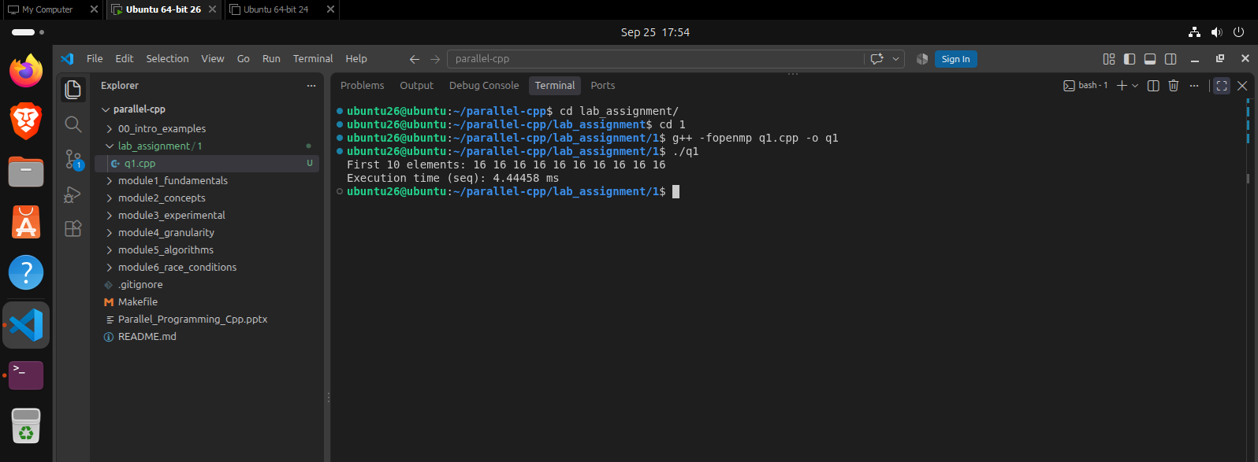

2. Calculate Cube of Each Element
Modify the program to calculate the *cube* of every element in the vector.
* Create a lambda cube.
* Use std::for_each(std::execution::seq, ...).
* Display the first 10 results.

Program
#include <iostream>
#include <vector>
#include <algorithm>
#include <execution>

int main() {
std::vector<int> vec = {1, 2, 3, 4, 5, 6, 7, 8, 9, 10, 11, 12};

// Lambda to calculate the cube
auto cube = [](int &n) {
n = n * n * n;
};

// Execute sequentially
std::for_each(std::execution::seq, vec.begin(), vec.end(), cube);

std::cout << "First 10 cubed results: ";
for (int i = 0; i < 10; ++i) {
std::cout << vec[i] << " ";
}
std::cout << "\n";

return 0;
}

OUTPUT
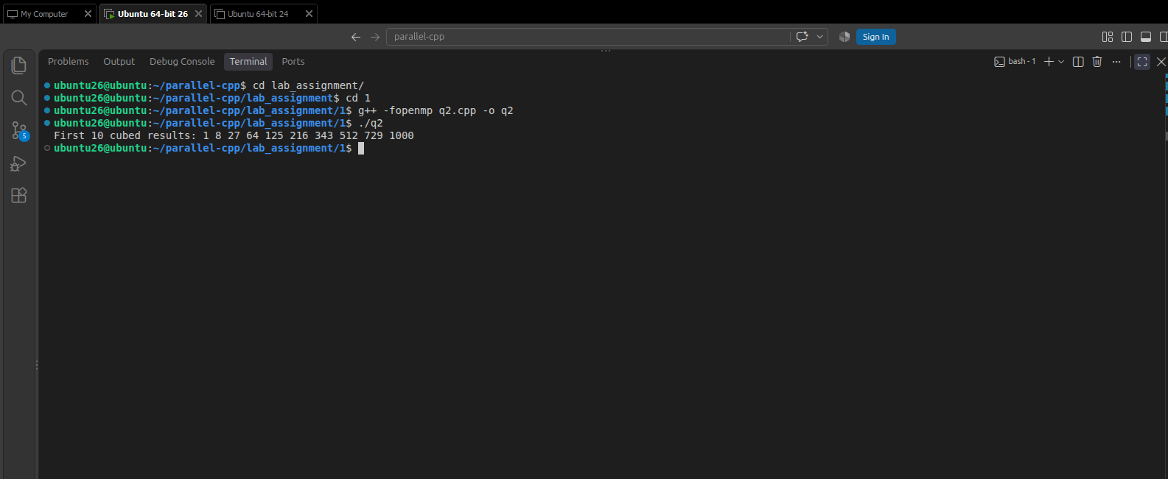

3. Sequential vs Parallel Addition
Create a vector of *1,000,000 integers*.
Use a lambda with std::for_each to add a fixed value, such as 10, to every element.
Run the operation using:
* std::execution::seq
* std::execution::par

Program

#include <iostream>
#include <vector>
#include <algorithm>
#include <execution>
#include <chrono>

int main() {
const int fixed_val = 10;
std::vector<int> vec_seq(1'000'000, 5);
std::vector<int> vec_par = vec_seq;

auto add_val = [fixed_val](int &n) {
n += fixed_val;
};

// Sequential Execution
auto start_seq = std::chrono::high_resolution_clock::now();
std::for_each(std::execution::seq, vec_seq.begin(), vec_seq.end(), add_val);
auto end_seq = std::chrono::high_resolution_clock::now();

// Parallel Execution
auto start_par = std::chrono::high_resolution_clock::now();
std::for_each(std::execution::par, vec_par.begin(), vec_par.end(), add_val);
auto end_par = std::chrono::high_resolution_clock::now();

std::chrono::duration<double, std::milli> duration_seq = end_seq - start_seq;
std::chrono::duration<double, std::milli> duration_par = end_par - start_par;

std::cout << "Sequential addition time: " << duration_seq.count() << " ms\n";
std::cout << "Parallel addition time: " << duration_par.count() << " ms\n";

return 0;
}

OUTPUT
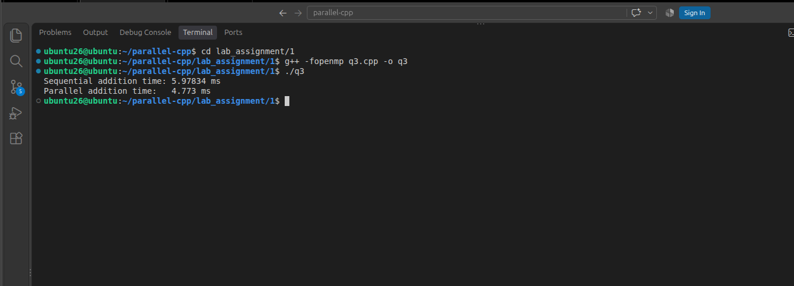

4. Apply a Simple Mathematical Operation
Create a vector containing values from 1 to 1,000,000.
Write a lambda that performs:
text
x = sqrt(x) + 1
Apply it using std::for_each.
Run the program using both *sequential and parallel execution policies* and display the
execution times.

Program
#include <iostream>
#include <vector>
#include <algorithm>
#include <execution>
#include <chrono>
#include <cmath>
#include <numeric>

int main() {
std::vector<double> vec_seq(1'000'000);
// Fill vector with values 1 to 1,000,000
std::iota(vec_seq.begin(), vec_seq.end(), 1.0);
std::vector<double> vec_par = vec_seq;

auto math_op = [](double &x) {
x = std::sqrt(x) + 1.0;
};

// Sequential Execution
auto start_seq = std::chrono::high_resolution_clock::now();
std::for_each(std::execution::seq, vec_seq.begin(), vec_seq.end(), math_op);
auto end_seq = std::chrono::high_resolution_clock::now();

// Parallel Execution
auto start_par = std::chrono::high_resolution_clock::now();
std::for_each(std::execution::par, vec_par.begin(), vec_par.end(), math_op);
auto end_par = std::chrono::high_resolution_clock::now();

std::chrono::duration<double, std::milli> duration_seq = end_seq - start_seq;
std::chrono::duration<double, std::milli> duration_par = end_par - start_par;

std::cout << "Sequential execution time: " << duration_seq.count() << " ms\n";
std::cout << "Parallel execution time: " << duration_par.count() << " ms\n";

return 0;
}
OUTPUT
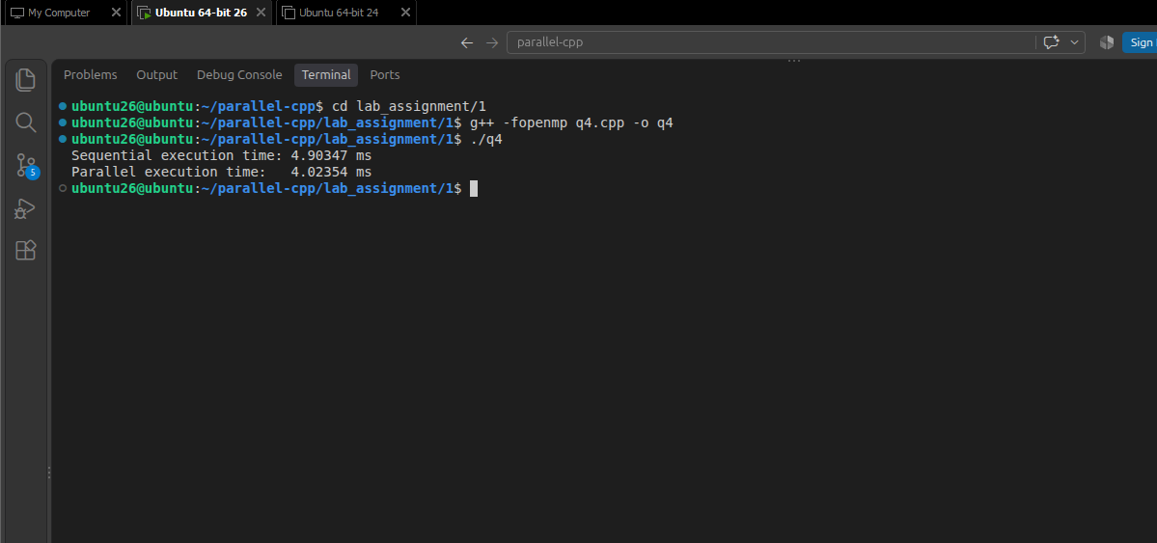

5. Lambda with a Captured Variable
Use the lambda concept from the introductory example, where a variable is captured by
value, such as [factor].
Create a vector of integers and use a lambda to multiply every element by a user-defined
factor.
For example:
text
factor = 5
[5, 10, 15, 20] → [25, 50, 75, 100]
Use std::for_each and try the operation with both seq and par.

Program
#include <iostream>
#include <vector>
#include <algorithm>
#include <execution>
#include <chrono>

int main() {
int factor = 5;
std::vector<int> vec_seq = {5, 10, 15, 20};
std::vector<int> vec_par = vec_seq;

// Capture 'factor' by value
auto multiply = [factor](int &n) {
n *= factor;
};

// Sequential Execution
auto start_seq = std::chrono::high_resolution_clock::now();
std::for_each(std::execution::seq, vec_seq.begin(), vec_seq.end(), multiply);
auto end_seq = std::chrono::high_resolution_clock::now();

// Parallel Execution
auto start_par = std::chrono::high_resolution_clock::now();
std::for_each(std::execution::par, vec_par.begin(), vec_par.end(), multiply);
auto end_par = std::chrono::high_resolution_clock::now();

std::chrono::duration<double, std::milli> duration_seq = end_seq - start_seq;
std::chrono::duration<double, std::milli> duration_par = end_par - start_par;

std::cout << "Result vector: ";
for (int val : vec_seq) {
std::cout << val << " ";
}
std::cout << "\n";

std::cout << "Sequential execution time: " << duration_seq.count() << " ms\n";
std::cout << "Parallel execution time: " << duration_par.count() << " ms\n";

return 0;
}

OUTPUT
